Lab Report – 2

Part A: Logic Levels

Moida Praneeth Jain (2022101093, Group 4, Table 16)

**Objective**

* To observe the LEDs’ brightness at different logic levels (voltage levels)

**Electronic Components Required**

* Power Supply
* Breadboard
* LEDs
* Resistors
* Wires
* Potentiometer
* IC 7404 (Hex Inverter)
* Multimeter

**The Reference Circuit**

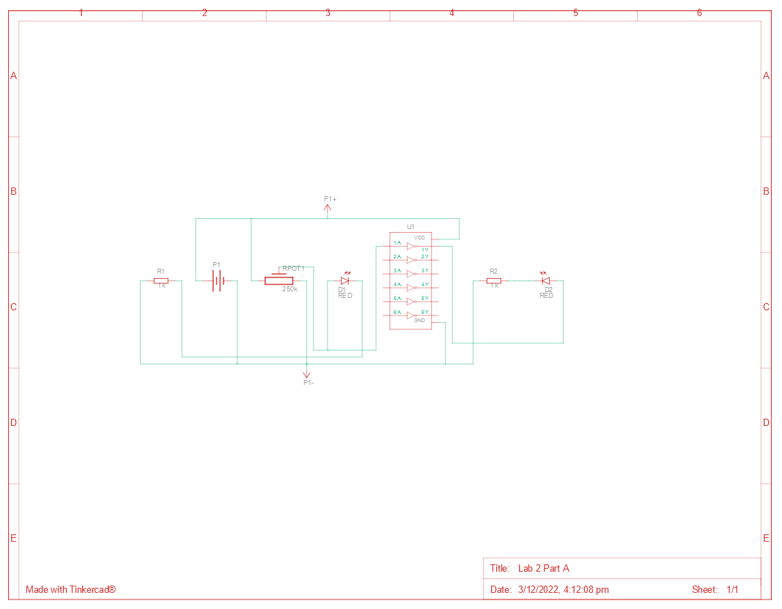

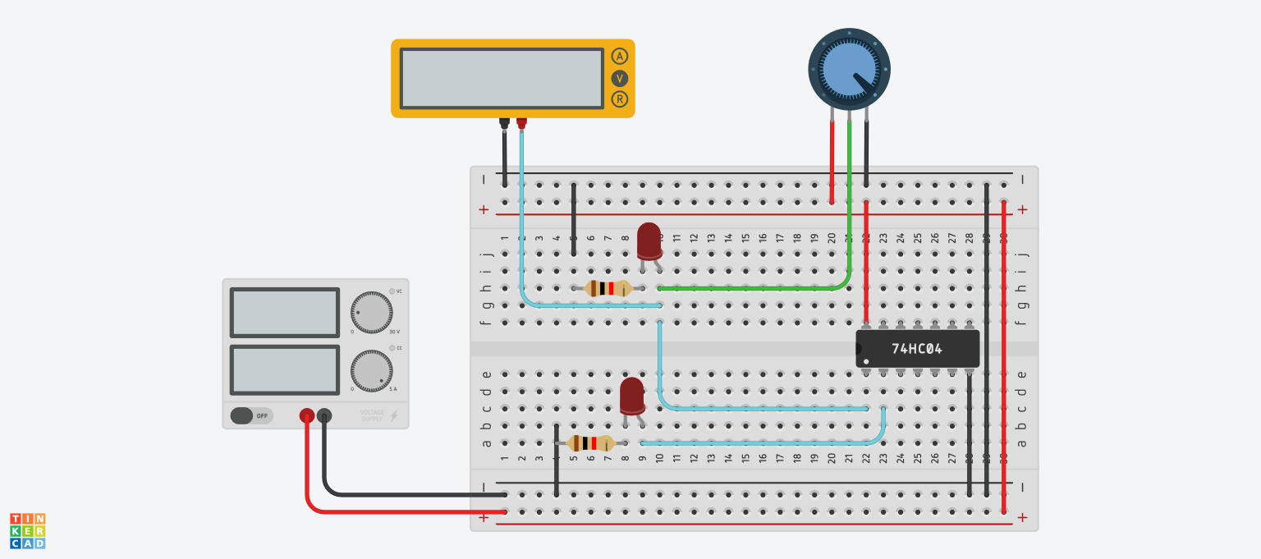

**Procedure**

* Connect the power and ground pins of the IC and potentiometer to VCC and GND respectively (using red and black wires).
* Connect the output of potentiometer to LED1’s anode, invert it using the hex inverter (7404), and connect it to LED2’s anode.
* Connect the LEDs’ cathode to GND through a resistor.
* Connect a multimeter such that it measures the voltage between LED1 and GND.

**Observation**

|  |  |  |  |
| --- | --- | --- | --- |
| No | LR1 | LR2 | Multimeter Voltage (V) |
| 1 | Dim | Glowing Bright | 0 |
| 2 | Dimly Glowing | Glowing Bright | 1.6 |
| 3 | Glowing | Glowing Bright | 1.8 |
| 4 | Glowing Bright | Dim | 5 |

**Conclusion**

* The voltage across LR1 decreases with increase in the resistance through the Potentiometer and LR2 glows brighter.

TinkerCAD simulation link:

<https://www.tinkercad.com/things/6RmzJFJBqfq-lab-2-part-a/editel?sharecode=72MZQZ4bZSIQV-2Q5DZZ90QI-8w5EuDKHFG-ueSCbyk>

Part B: Gate Identification

Moida Praneeth Jain (2022101093, Group 4, Table 16)

**Objective**

* Find out the logic function of each of the given ICs.
* Find out the pin connections of each of the given ICs.

**Electronic Components Required**

* Power Supply
* Breadboard
* LED
* Resistor
* Switches
* Wires
* ICs (7404, 7402, 7432, 7408, 7486, 7400)

**The Reference Circuit**

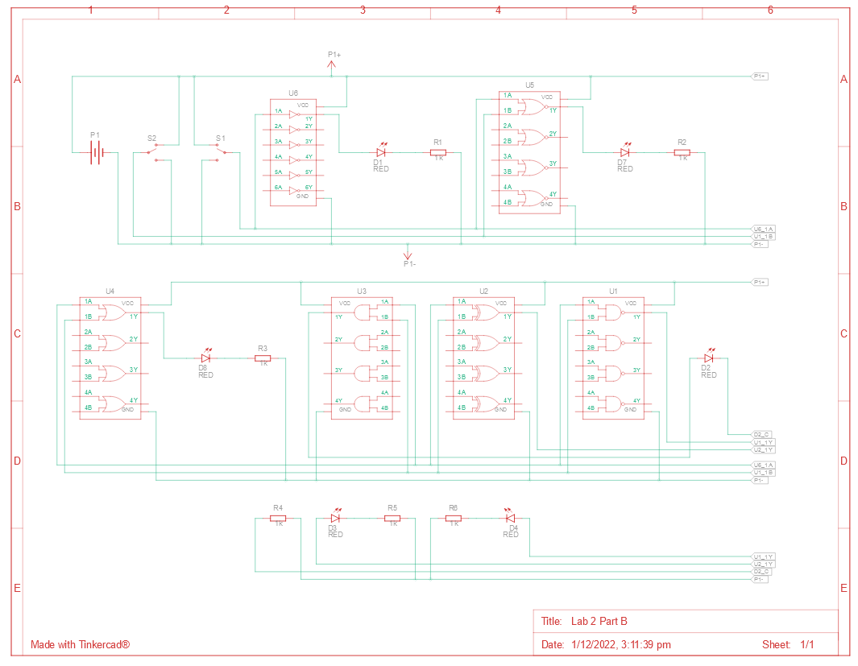

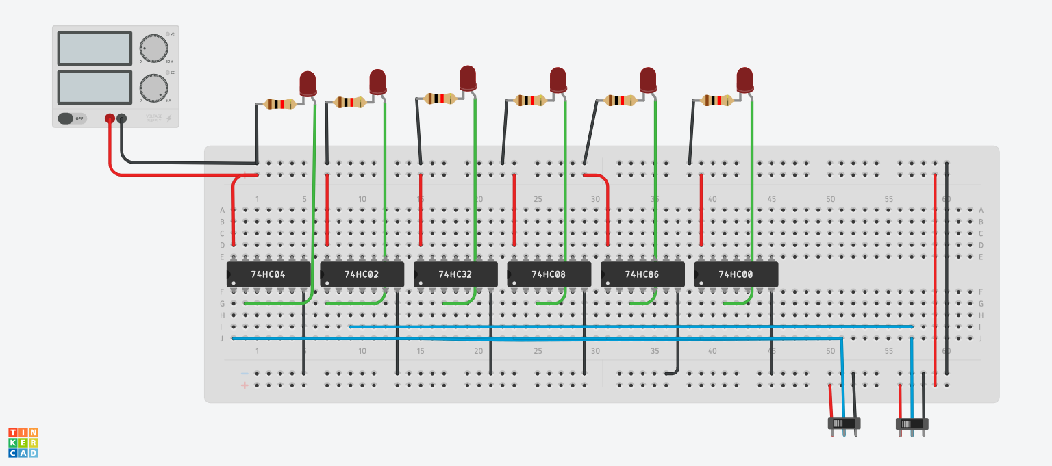

**Procedure**

* Connect the ground and power pins of each of the ICs to GND and VCC respectively (using black and red wires respectively).
* Connect the switch inputs to each of the ICs.
* Connect the output of the ICs to an LED’s anode.
* Connect LED’s cathode to GND through a resistor.
* Turn the power supply on.
* Record the readings to find the truth tables of the ICs.

**Observation**

|  |  |  |  |  |  |  |  |
| --- | --- | --- | --- | --- | --- | --- | --- |
| Switch 1 | Switch 2 | 7404 | 7402 | 7432 | 7408 | 7486 | 7400 |
| 0 | 0 | 1 | 1 | 0 | 0 | 0 | 1 |
| 0 | 1 | 1 | 0 | 1 | 0 | 1 | 1 |
| 1 | 0 | 0 | 0 | 1 | 0 | 1 | 1 |
| 1 | 1 | 0 | 0 | 1 | 1 | 0 | 0 |

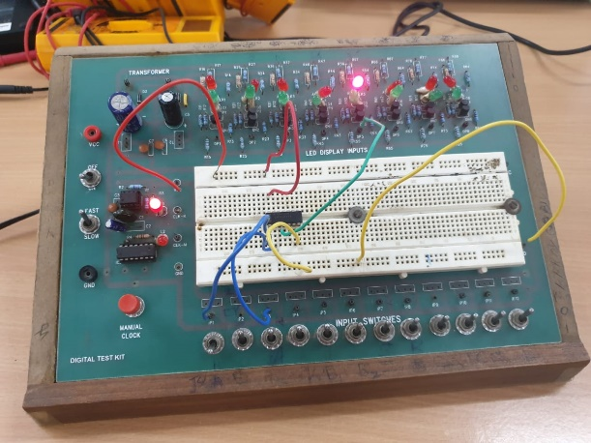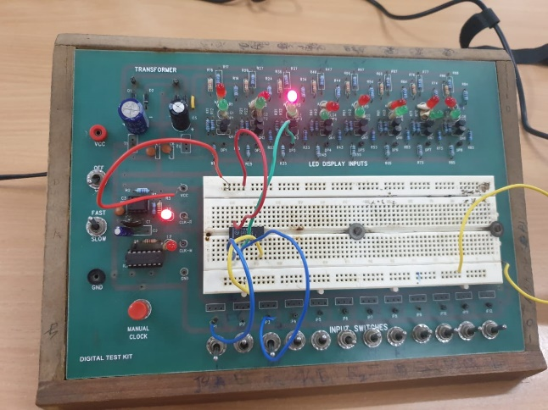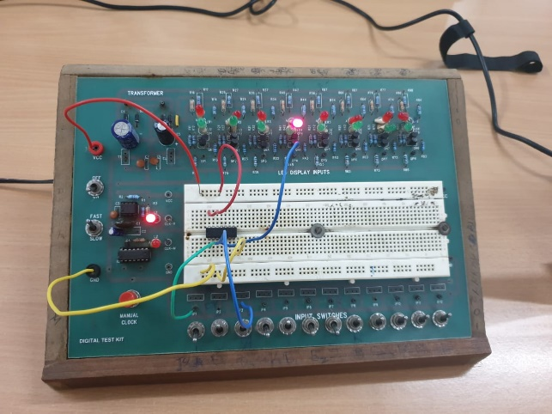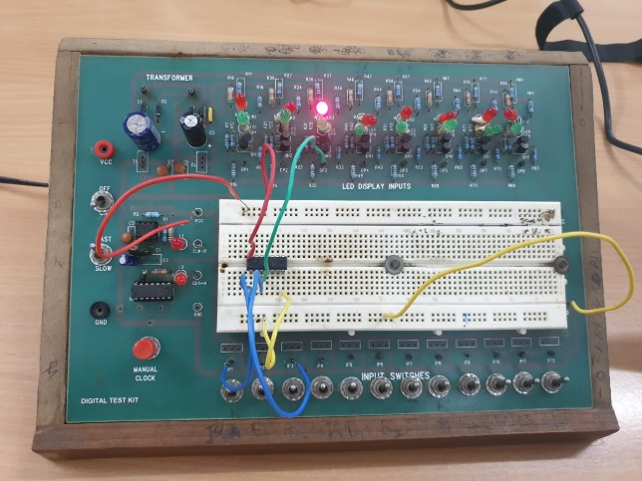

**Conclusion**

* 7404: NOT Gate
* 7402: NOR Gate
* 7432: OR Gate
* 7408: AND Gate
* 7486: XOR Gate
* 7400: NAND Gate

TinkerCAD simulation link:

<https://www.tinkercad.com/things/6kYfpYkRI42-lab-2-part-b/editel?sharecode=rqMKvX9NTtE-BJuA9yrV_-O7Y-uGwjljVLuSqDb-_0w>

Part C: De Morgan’s Theorems

Moida Praneeth Jain (2022101093, Group 4, Table 16)

**Objective**

* Verify De Morgan’s Laws of conjunction and disjunction.

**Electronic Components Required**

* Power Supply
* Wires
* Breadboard
* LED
* Switches
* Resistor
* NAND Gate (7400)
* AND Gate (7408)
* OR Gate (7432)

**The Reference Circuit**

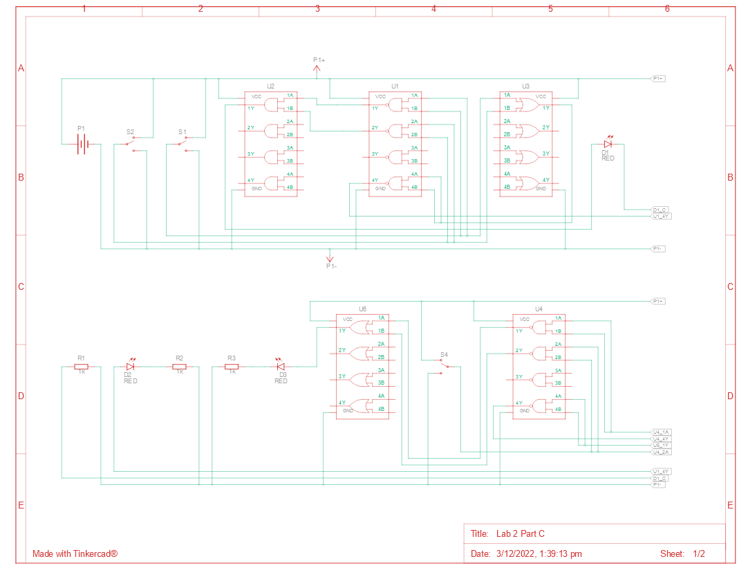

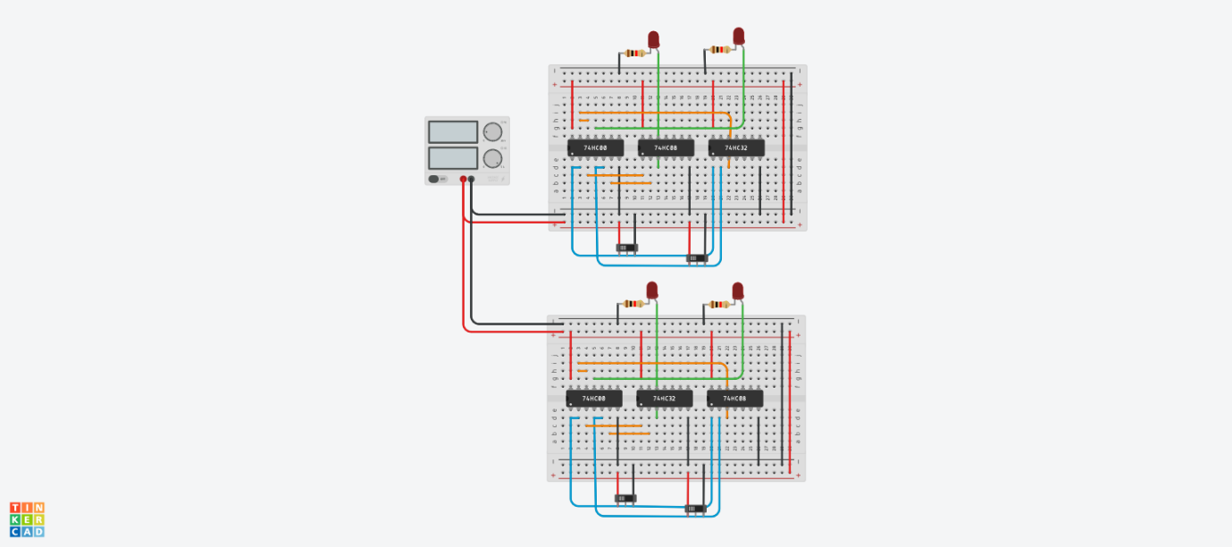

**Procedure**

* Connect the ground and power pins of each of the ICs to GND and VCC respectively (using black and red wires respectively).
* NOT the first input by splitting it into two and using the NAND gate. Similarly, NOT the second input. AND both of these and connect the output to an LED’s anode. Connect the output of the cathode of the LED with GND through a resistor. This is (A’.B’).
* OR the two inputs and then NOT it by splitting the output into two and using the NAND Gate. Connect this to the cathode of the LED with GND through a resistor. This is (A+B)’
* Swap the AND and OR gates in the above circuit. The LEDs will now represent (A’+B’) and (A.B)’.

**Observation**

* Both the LEDs have the same state for all possible inputs.

**Conclusion**

* (A+B)’ = (A’.B’)
* (A.B)’ = (A’ + B’)

TinkerCAD simulation link:

<https://www.tinkercad.com/things/kGSTaqC9sQM-lab-2-part-c/editel?sharecode=4oloDzMQEcr6Si1Ow6-RXj8Pj0zfSQD4WaEJQYbucmA>

Part D: Full Bit Adder

Moida Praneeth Jain (2022101093, Group 4, Table 16)

**Objective**

* Create a full bit adder to add 3 bits and display the sum in binary using LEDs.

**Electronic Components Required**

* Power Supply
* Breadboard
* Wires
* LED
* Resistor
* Switches
* XOR Gate (7486)
* AND Gate (7408)

**The Reference Circuit**

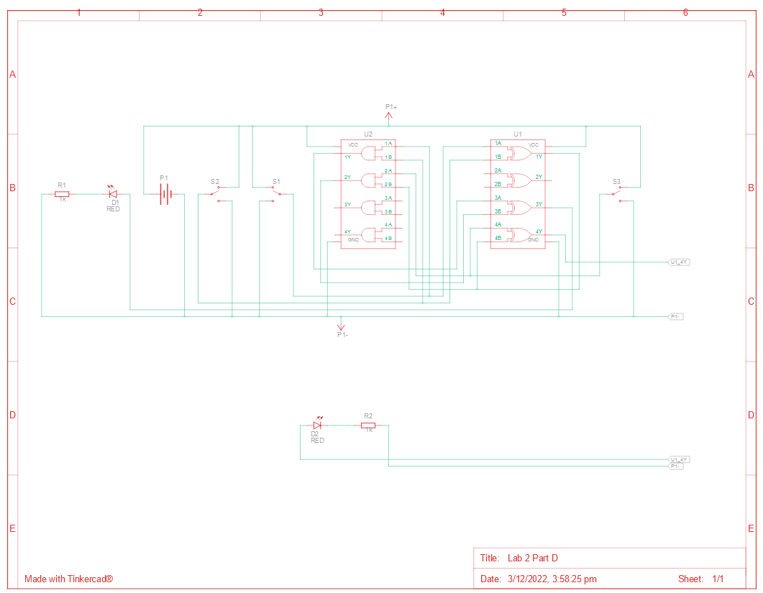

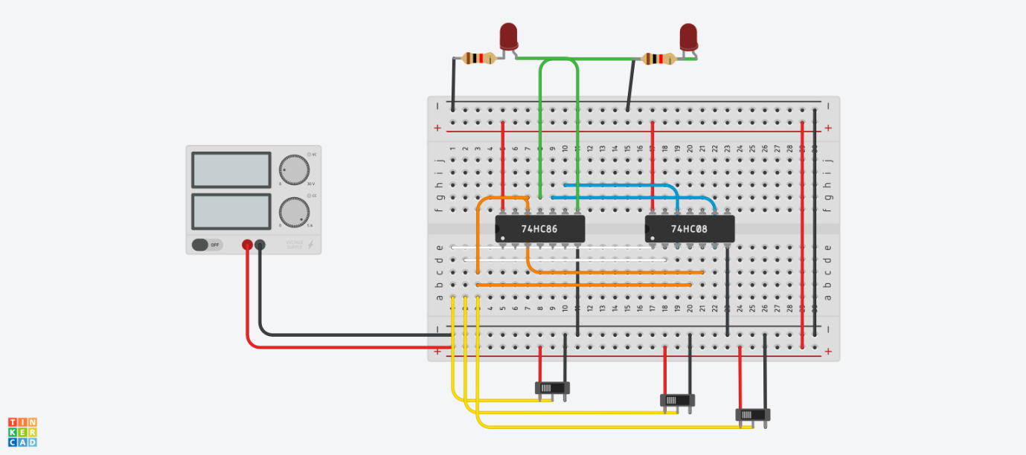

**Procedure**

* Carry = X ⊕ Y ⊕ Z, Sum = (Z . (X⊕Y)) ⊕ (X.Y)
* Connect the power and ground pins of the ICs to VCC and GND respectively (using red and black wires).
* Connect the inputs with the respective gates to get the carry and the sum according to the formulae above.
* Connect the outputs to the anode of the LEDs.
* Connect the cathode of the LEDs to GND through a resistor.

**Observation**

|  |  |  |  |  |
| --- | --- | --- | --- | --- |
| X | Y | Z | CARRY | SUM |
| 0 | 0 | 0 | 0 | 0 |
| 0 | 0 | 1 | 0 | 1 |
| 0 | 1 | 0 | 0 | 1 |
| 0 | 1 | 1 | 1 | 0 |
| 1 | 0 | 0 | 0 | 1 |
| 1 | 0 | 1 | 1 | 0 |
| 1 | 1 | 0 | 1 | 0 |
| 1 | 1 | 1 | 1 | 1 |

* The output of the full bit adder is:

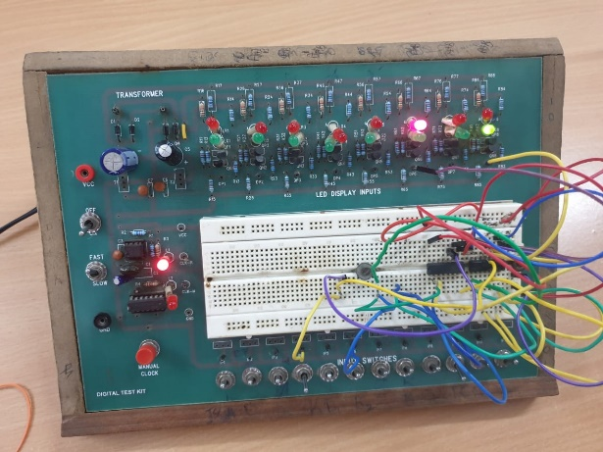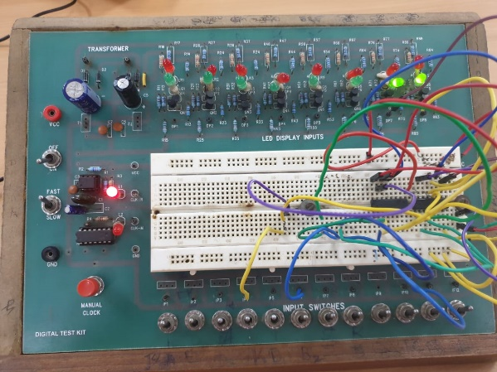

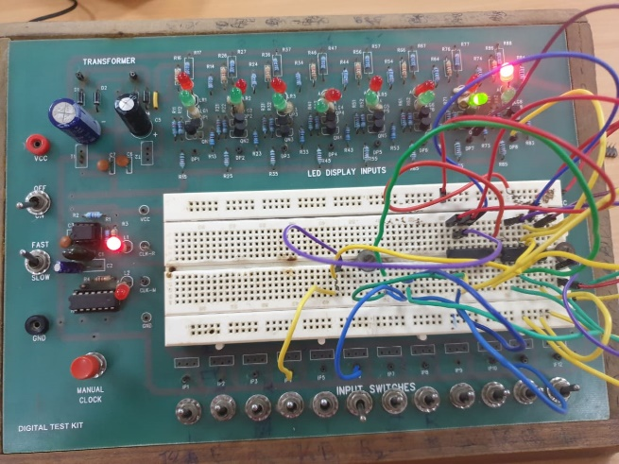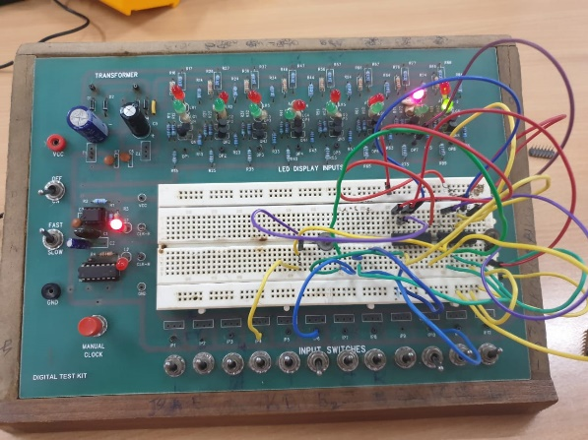

**Conclusion**

* The full bit adder works as expected.

TinkerCAD simulation link:

<https://www.tinkercad.com/things/i5lmmiaHD2W-lab-2-part-d/editel?sharecode=3kNuKGQxbr1dwDp9xyKTUy3Vg6z0_ElJixQZhhbHNBA>